September 9, 2020

His Divine Holiness Bhagavan Sri Nithyananda Paramashivam
Supreme Pontiff, Jagatguru Mahasannidhanam
KAILASA Nation

Your Divine Holiness,

On behalf of The Dietrich Bonhoeffer Institute, it is my pleasure to congratulate and recognize the revival of KAILASA Nation through the 40th Chaturmasya (Seasonal Hindu Austerities) Anniversary of His Divine Holiness Bhagavan Sri Nithyananda Paramashivam, the Supreme Pontiff of Hinduism, Jagatguru Mahasannidhanam, recognized as the 1008th living incarnation of Paramashiva as per Hinduism by His predecessors of enlightened masters and adepts.

His Divine Holiness has worked tirelessly for the past 40 years to improve the physical, mental, emotional, and spiritual well-being of all people through the revival of the ancient sciences of the Ved-Agamas (Hindu scriptures) using Yoga, Ayurveda, Dhyana (Meditation) and Pranayama (breath control) throughout the world—irrespective of nationality, religion, race, gender, or economic status.

KAILASA, as a borderless nation, with spiritual embassies operating in over 100 countries, including the United States of America, has the largest Hindu spiritual resource on the Internet, enriching more than 1 billion lives for the past 26 years.

In this Year of 2020, we rejoice in the 40th Celebrations of the Revival of KAILASA Nation and appreciate the contribution of the KAILASA Nation and His Divine Holiness Bhagavan Nithyananda Paramashivam to the world and look forward to cultivating this strong and lasting relationship between KAILASA Nation and The Dietrich Bonhoeffer Institute.

Very Respectfully,

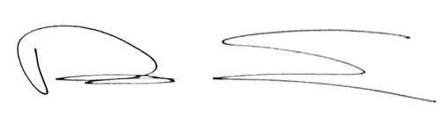

Rev. Dr. Rob Schenck
President
The Dietrich Bonhoeffer Institute

